Preparation and Maintenance of ZOHO Books for Fresh Bites Catering (Food and Beverage - Industry)

**Project Team members: DHESIHA.M**

**FATHIMA.K**

**FAZILATH NISHA.K**

**JULBIYA.T**

1. **INTRODUCTION**

**1.1 Overview:**

This project is deal with Fresh Bites Catering, a catering service, utilizes Zoho Books to manage their sales, track inventory, and handle invoicing. They can generate professional invoices for clients and track expenses related to ingredients and supplies. Zoho Books helps them maintain accurate financial records and streamline their catering operations.

**1.2 Purpose:**

By maintenance of accounts in ZOHO Books, We have created the Items, Vendors creation, Preparation of Purchase Order, Purchase Invoice, Customer creation, Preparation of Sales order, Sales Invoice, creation of bank account, creation of new accounts, recording journal entries, recording expenses, recording bank receipts and payments and viewing of financial reports like Profit & Loss account, Balance sheet, GST Reports, Journal report, Account receivable summary report, Account payable summary report, etc.

1. **Problem Definition & Design Thinking**
   1. Empathy Map

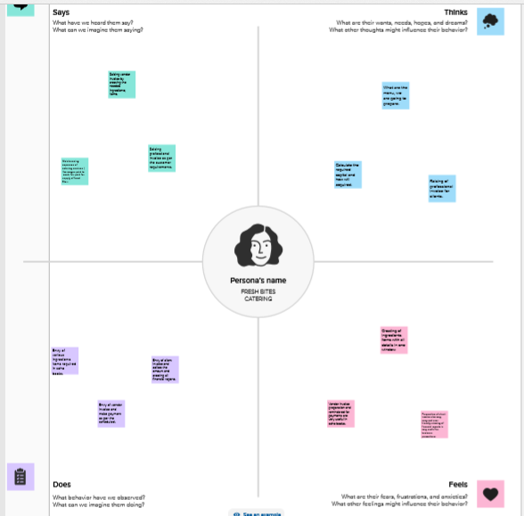

2.2 Ideation & Brainstorming Map

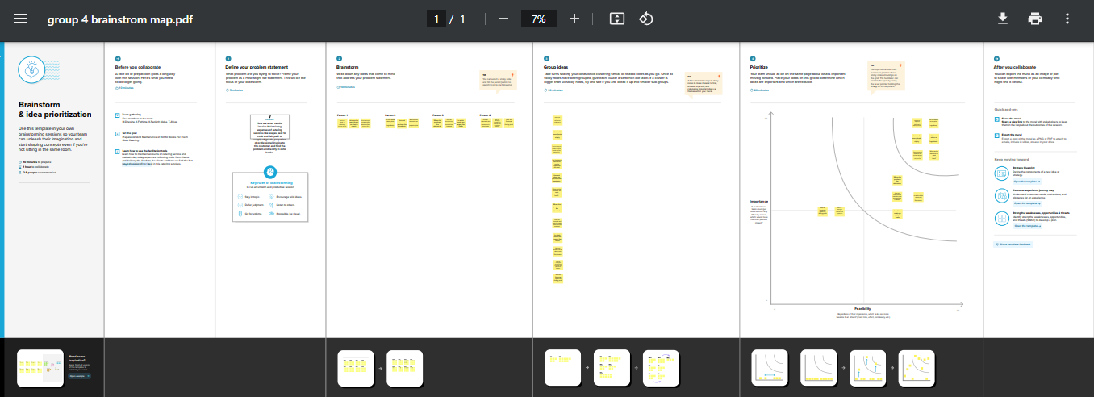

1. **RESULT:**

To Generate the Financial Reports:

1.Profit and Loss Account:

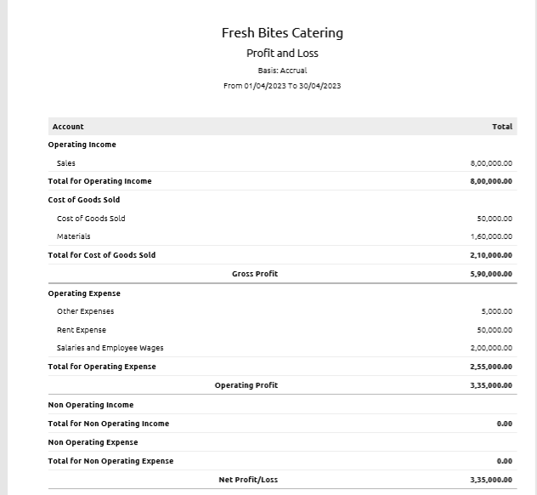

2.Balance Sheet

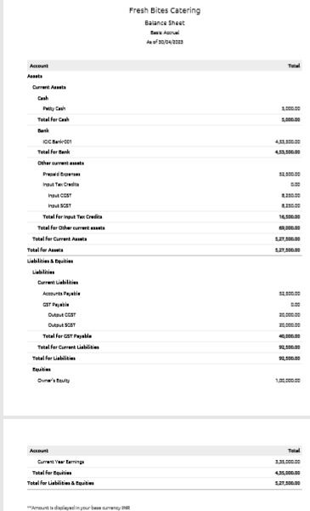

3.GST Reports

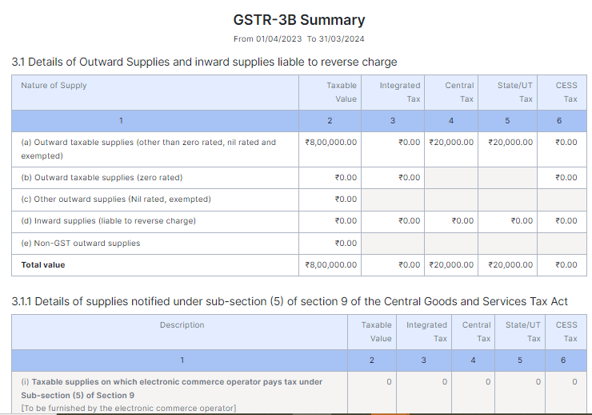

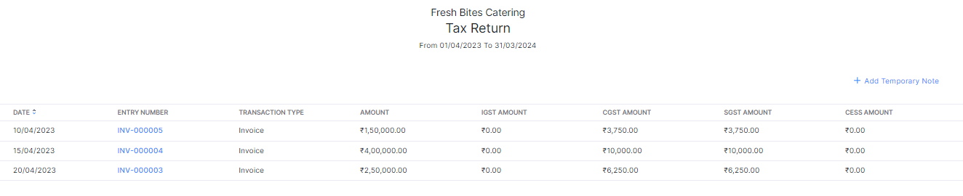

1. Journal Report

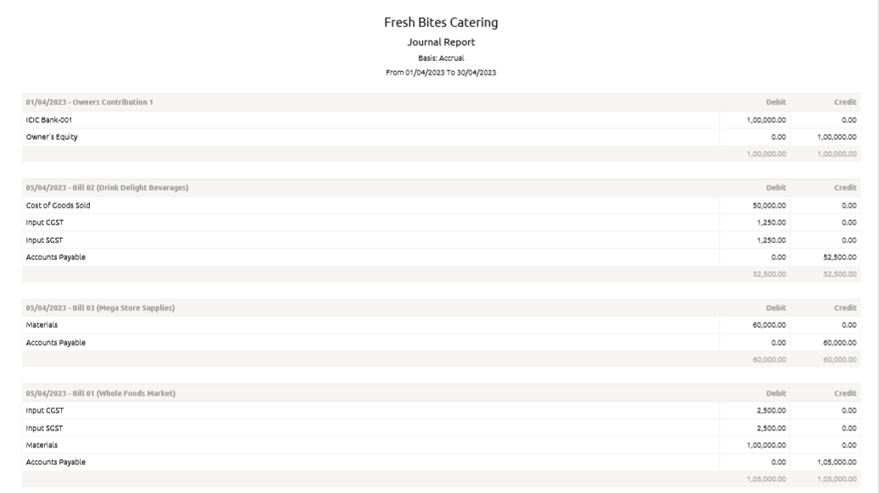

5.Accounts Receivable Summary

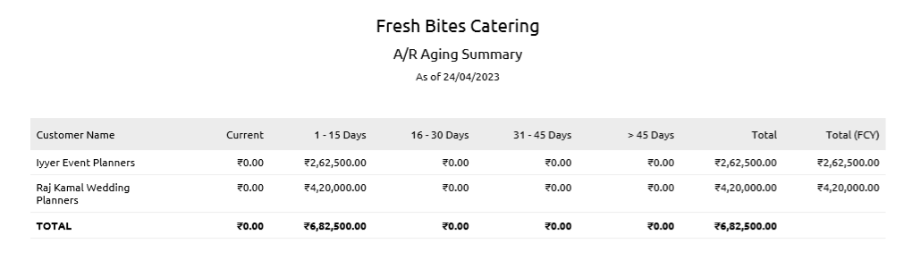

6.Accounts Payable Summary

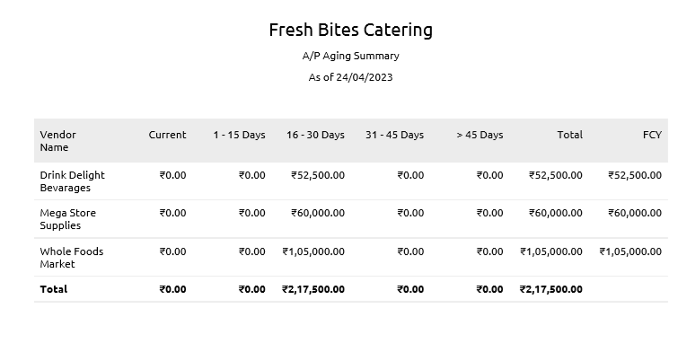

**4. ADVANTAGES & DISADVANTAGES**

List of advantages:

* ZOHO books is cloud based software, so we access the software in any location.
* Creating of Organistion is very easy and user friendly.
* Appearance of software model is very easy to understanding.
* Creation of items, vendors, customers are user friendly while compare with software
* Preparation of purchase order and conversation to purchase Invoice made in a single step.
* Preparation of Sales order and conversation to Sale Invoice made in a single step.
* Default accounting step up is very useful and time saving.
* GST procedure is very easy to enter.
* Getting financial report and tax report in single step.

List of disadvantages:

* ZOHO books is cloud based software, which need internet and other technical facility.
* In absence of internet facility, the working in ZOHO books is very difficult.
* There is no secure in data of the organization.

**5. APPLICATIONS:**

* The ZOHO Books is good software in all type of organization and we get better results instantly. We collect the following data and entered in ZOHO Books in various modules like item creation, Vendor creation, customer creation, preparation of Purchase order, Purchase Invoice, sales order, sale Invoice, Making payment to vendors and Expenses, Received amount from Customers.

**Item creation:**

Lets Assume Fresh Bites Catering is offering below services:

1. Corporate Catering Rs.300/- per plate

2. Wedding Catering Rs.400/- per plate

3. Buffet Catering Rs.500/- per Plat

Output GST @ 5% is applicable for the above services.

It requires below Purchase items for the supply of above services:

1. Food Ingredients ( Cost price is Rs.500/- per Kg)

2. Beverages (CP is Rs.100/- each)

3. Catering Supplies (CP is Rs.300/- each)

**Vendor creation:**

1. Whole Foods Market (GST registered)

2. Drink Delight Bevarages (GST registered)

3. Mega Store Supplies (Non GST)

**Customer creation:**

1. TechWise Solutions Pvt Ltd (GST Registered).

2. Raj Kamal Wedding Planners (GST Registered).

3. Iyyer Event Planners (Non GST)

**Preparation of Purchase order, Purchase Invoice:**

1. 05-04-2023 Whole Foods Market – Food Ingredients - Qty 200 - GST @ 5%

2. 05-04-2023 Drink Delight Bevarages – Beverages- Qty 500

3. 05-04-2023 Mega Store Supplies- Catering Supplies- Qty 200

**Preparation of sales order, sale Invoice:**

1. 10/04/2023 Techwise Solutions – Corporate Catering for 1000 plates - paid through bank on 15/04/2023

2. 15-04-2023 Raj Kamal Wedding Planners- Wedding Catering for Qty 1000 Plates

3. 20-04-2023 Iyyer Event Planners – Buffet Catering for Qty 500 plates

**Making payment to vendors and Expenses**

1. Employee salaries of total Rs.2,00,000/- paid through bank on 30th April 2023.
2. Office Rent Rs.50,000/- excluding GST @ 18% Total Invoice Value Rs.59,000/- paid in Bank.
3. Other Miscellaneous Expenses Rs.5,000/- paid in cash
4. 25-04-2023 Paid to Whole Foods Mart 105000
5. 25-04-2023 Paid to Drink Delight Bevarages 52500
6. 25-04-2023 Paid to Mega Store Supplies 60000

**Received amount from Customers:**

15-04-2023 Amount received from Techwise Solutions Pvt Ltd 157500

25-04-2023 Amount received from Raj Kamal Wedding Planners 42000

25-04-2023 Amount received from Iyyer Event Planners 262500

**6. CONCLUSION:**

In maintain of Fresh Bites Catering accounts in Zoho books is very smart in all the aspects of entries. The basic accounting concept is enough for the operating person (Accountant/Data entry operator). This software is applicable for all types of organization. The entry models of software are easily understood and interest to work. Whatever reports we need, it’s already default in the report models. Totally it’s a good and very useful to the entire entrepreneur with low cost for operating financial department.

**7. FUTURE SCOPE:**

The idea for the founders of ZOHO Books is amazing and very clever. This is a great milestone in the field of accounts maintenance. They offer various plane as per the requirement of the proprietors. It’s a good gift to all the entrepreneurs.